Lecture 13

CPSC 131  
11/16/2020

1. Rotation in Binary Trees
   1. 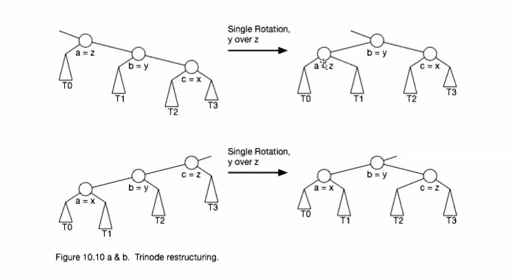
   2. Start with an empty tree, insert nodes beginning with 14  
      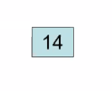
   3. Insert 17 and 11 (so far balanced)  
      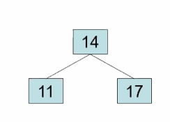
   4. Insert 7 (still balanced)  
      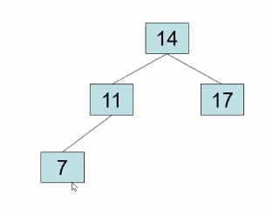
   5. Add 53 (still balanced)  
      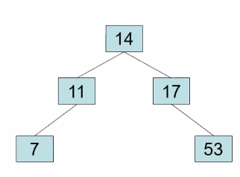
   6. Add 4 (still balanced)  
      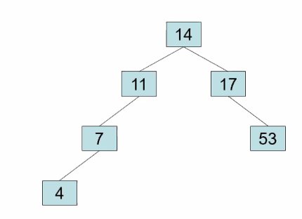
   7. Here is where rotation at 7 will bring us  
      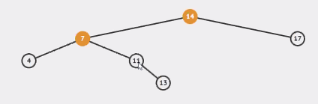
      1. The offending nodes are 14 and 7 as they are the ones that act as the rotation points.
   8. What we’re trying to say is that rotation can be applied to not only children but also the root when it comes to certain circumstances. Rotation consists of the process of inserting and re-inserting nodes to balance out the tree.
   9. Remember trinode restructuring? That’s essentially what rotation is.   
      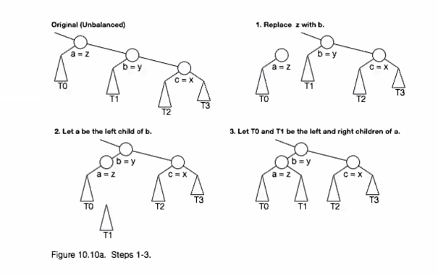  
      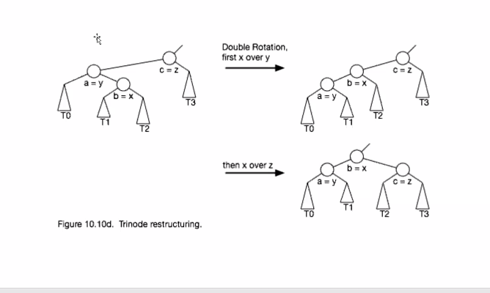
   10. Eventually with the addition of 17  
       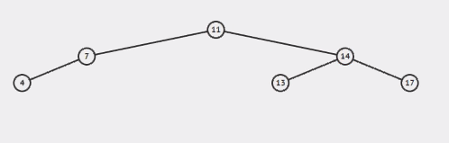
       1. After three rotations, we finally get the final tree
   11. Now insert 12  
       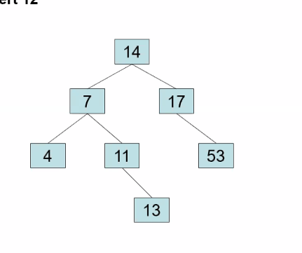





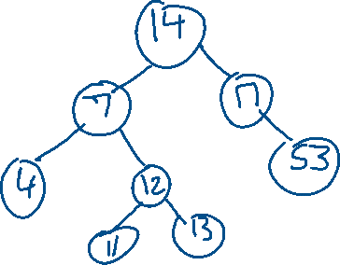

* + 1. Now insert 8  
       Before rotation  
       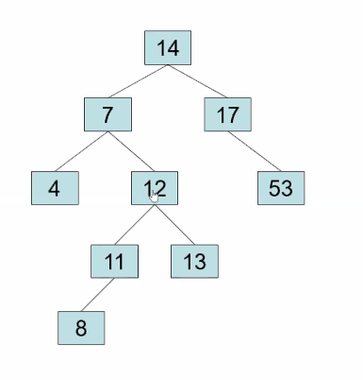
    2. After Rotation 1  
       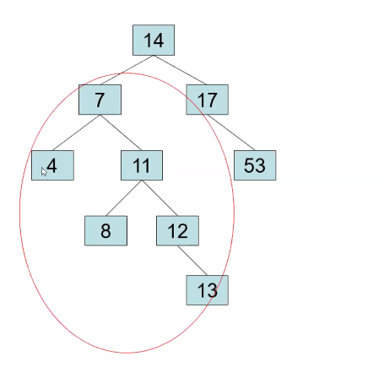
  1. After Rotation 2  
     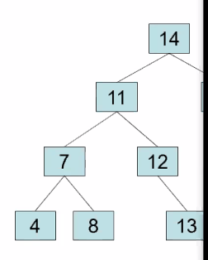
     1. Never mind the right subtree
  2. Now let’s remove 53
     1. 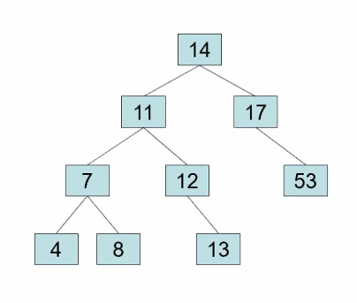



* 1. Restructure  
     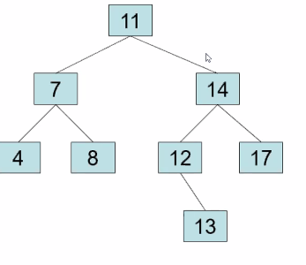
  2. Now let’s remove 11  
       
       
       
       
       
       
       
       
       
     or  
     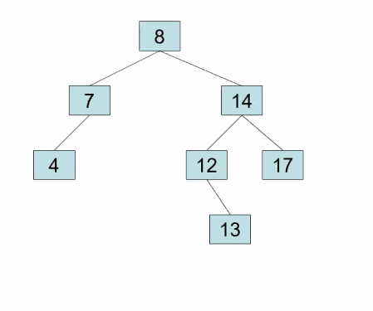

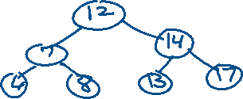

* 1. Let’s remove 8

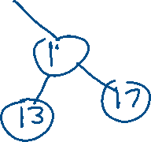

1. No class next Monday and Wednesday